**Project Planning Phase**

**Project Planning Template (Product Backlog, Sprint Planning, Stories, Storypoints)**

|  |  |
| --- | --- |
| Date | 28 October 2022 |
| Team ID | PNT2022TMID32830 |
| Project Name | Project – Flight Delay Prediction |
| Maximum Marks | 8 Marks |

**Product Backlog, Sprint Schedule, and Estimation (4 Marks)**

Use the below template to create product backlog and sprint schedule

| **Sprint** | **Functional Requirement (Epic)** | **User Story Number** | **User Story / Task** | **Story Points** | **Priority** | **Team Members** |
| --- | --- | --- | --- | --- | --- | --- |
| Sprint-1 | Registration | USN-1 | As a user, I can register for the application by entering my email, password, and confirming my password. | 2 | High | Karolin Kiruba R |
| Sprint-1 | User confirmation | USN-2 | As a user, I will receive confirmation email once I have registered for the application | 1 | Medium | Srijane A |
| Sprint-1 | Login | USN-3 | As a user, I can log into the application by entering email & password | 1 | High | Arsah A |
| Sprint-2 | Analyse | USN-4 | I can analyse the dataset | 2 | Medium | Kishan I |
| Sprint-3 | Develop and train | USN-5 | I can develop and train the model to predict the flight delay | 2 | High | Neekitha C |
| Sprint-4 | Application | USN-6 | Shows the flight details | 2 | High | Arsah A, Karolin Kiruba R, Kishan I, Neekitha C,Sri Jane A |

**Project Tracker (4 Marks):**

| **Sprint** | **Total Story Points** | **Duration** | **Sprint Start Date** | **Sprint End Date (Planned)** | **Story Points Completed (as on Planned End Date)** | **Sprint Release Date (Actual)** |
| --- | --- | --- | --- | --- | --- | --- |
| Sprint-1 | 20 | 6 Days | 24 Oct 2022 | 29 Oct 2022 | 20 | 29 Oct 2022 |
| Sprint-2 | 20 | 6 Days | 31 Oct 2022 | 04 Nov 2022 | 20 | 04 Nov 2022 |
| Sprint-3 | 20 | 6 Days | 07 Nov 2022 | 11 Nov 2022 | 20 | 11 Nov 2022 |
| Sprint-4 | 20 | 6 Days | 14 Nov 2022 | 19 Nov 2022 | 20 | 19 Nov 2022 |

**Flight delay prediction – Burndown chart**

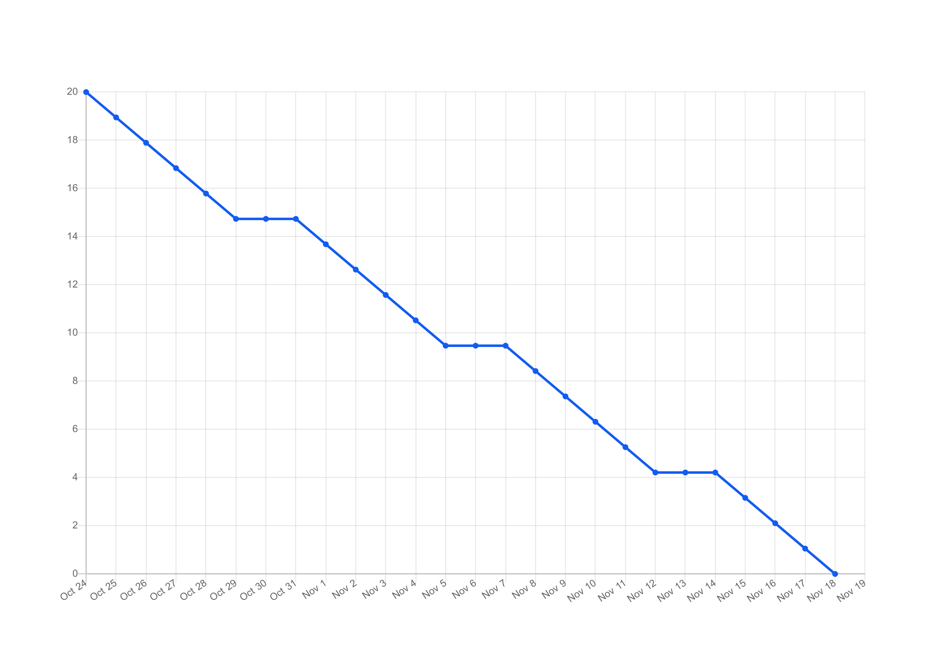

**VELOCITY**

(Sprint – 1 ) Velocity = 4/20 = 0.020

( Sprint – 2 ) Velocity = 2/20 = 0.1

( Sprint – 3 ) Velocity = 2/20 = 0.1

( Sprint – 4 ) Velocity = 2/20 = 0.1